Computer Science

A2 Coursework

Callum Reid

**Discussion Chapter:**

I am going to create an organisational database system for Bayburn Fitness, a local fitness group in my town that I attend. There is one main manager and several fitness trainers across multiple locations including: Helen’s Bay, Hollywood and Conlig however it originated in Helen’s Bay which is where I attend every weekday. The company has been going for over 2 years now and boasts over 120 regular clients at the Helen’s Bay location. Bayburn fitness runs classes Monday to Saturday. Where they run an average of 3 classes per day for all levels of physical fitness and capability to ensure a wide range of clients can be attended to. They do circuit style training which can be tailored by the trainer to support any client’s personal goals or wants.

**Identifying The Problem:**

The main problem with the fitness club is that the records regarding clients, classes and timetables are not organised efficiently. They are kept on large Excel files but there is no organisation within these files and these separate excel spreadsheets are not linked and it is leading to redundant data, incorrect and in some cases invalid data. This is an issue for the business as it can cause loss of reputation and trust from a client's point of view, delays in accessing, modifying records, and potential loss of earnings.

One of the main problems is that a note of who went to what class has to be kept on a simple excel spreadsheet which is not very efficient and the only way for a client to know details about classes, times, locations and cancelations is through a WhatsApp group chat with over 120 members which can become cluttered very quickly making it difficult for information to be found. This means that people can end up traveling to a location not aware that a class has been cancelled. It also means that data about what classes are for what people can be difficult to find resulting in people ending up in classes which are too intense for them or not intense enough. Communication in this type of business is key to it being successful and this is a definite area for development and improvement.

As more people join Bayburn Fitness more people will join the WhatsApp group chat and more people will have to be recorded on the excel spreadsheet at a time meaning information will become difficult to find and if data is not entered correctly into the excel spreadsheet. The company may not claim money from people who went to a class therefore resulting in a loss of money due to confusion on who has booked or attended classes and who has not. Another issue that has arisen from the success of the business is that because more people have joined it now becomes necessary to maintain and manage these records in line with GDPR regulations. Each individual may have specific needs and/or issues and the old Excel system can only work with a small number of clients.

Another problem is that the WhatsApp group chat has a maximum number of participants which means eventually multiple group chats will be necessary and the transfer of information from managers and trainers to clients will become more complex than it should be resulting in more confusion. Part of this confusion comes from the fact that there is currently no way for the manager to generate reports without searching through hundreds of past files to find data and information. Another problem is that classes are not well organised simply through the WhatsApp group chat due to its cluttered nature. This means that booking classes and keeping track of who has attended what classes along with who has or has not paid for their class becomes difficult.

Another issue is the demands of new clients. In this day and age clients are looking more to see the benefits of the work that they are putting in - this needs to be in data form rather than anecdotally via the trainers. Tracking of fitness through the classes can really bring the business in line with competitors.

**Proposed Solution:**

I plan on creating a digital database system which will allow a manager to add clients and trainers into the database with all necessary personal information. It will allow trainers to create classes with times, dates, locations and what type of class it is. And it will allow clients to book into these classes and cancel their bookings easily. There should also be an information board which clients can read but only managers and trainers can add to in order to make information easier to find. The system will also have a fitness tracker for clients where the client can track their progress for individual exercises such as dead lift etc.The database system should have an intuitive graphical user interface which will make it easier to navigate. The system will allow the manager to produce reports on the system that will maximise the efficiency of the business looking at maximising the use of the trainers, the running of classes. The system will allow the manager to make business decisions based on facts recorded by the system - the system will show patterns and trends to allow the manager to do this. The database will be created in MySQL however it will be manipulated and edited using python and the python to MySQL connector allowing for data to be stored quicker and easier.

**Scope:**

The system I plan on creating will be capable of allowing managers to easily and in a timely manner, add new clients to the database along with all relevant personal data and generate reports and graphs on the amount of bookings within a certain time period for a certain location, time slot, class type or trainer in order to get an idea of what technique of running the business is most profitable.

I plan on allowing the system to let trainers add classes in the same way you would set an alarm clock, for example the trainer will be able to set what days of the week and what time the class starts at, for how long the class will run and if the class will repeat weekly, the trainer will also be able to define what type of class it will be and with what trainer, this is to make it easy for a trainer to create, edit and delete classes.

The system should also allow clients to open up a calendar and select any date to see if there are classes on that date and if there are, they should be able to book them with the press of a button. The client should also have access to all the bookings that they have made and be able to cancel them freely. The clients view of the booking will show them when and where the class is being held, by which trainer, for how long the class will run and what type of class it will be. The client should also be able to see their tracking data for certain exercises over a period of time. This will allow them to see their improvement.

The trainers will also have access to a screen which will allow them to see who has booked into their classes and the manager will have access to a screen which will show them all bookings. The manager, trainers and clients will all have access to an information board however only managers and trainers will be able to edit this board.

The system should also allow clients to generate their own personal fitness plan or routine that is tailored to their needs or goals. This should be auto generated by the system after the client inputs what aspect or aspects of fitness they want to improve. They should also be able to track their fitness progress using the system.

**Stakeholders:**

There are three main stakeholders in this system: the manager of Bayburn Fitness, the trainers and the clients.

**Initial system requirements:**

General:

* The system must make it easier for clients to access information.
* The system must make it easier for the manager to see who has

attended which classes.

* The system must use a database.
* The system must be able to generate a variety of reports based on bookings.
* The system must be able to manage the booking of classes for clients.
* The system must make it easier for trainers to make classes available for clients.
* The system must help to increase the overall fitness of clients

Manager:

* The system must allow a manager to add a client and all appropriate information about them.
* The system must allow a manager to access and edit an information board.
* The system must allow a manager to generate reports and graphs based on the bookings in a specific time period. This will allow the manager to make business decisions based on the data and the trends shown in the data.

Trainers:

* The system must have a system to allow trainers to create classes which can be booked into by clients.
* The system must allow a trainer to view all the people that have booked into their classes.
* The system must allow a trainer to access and edit an information board.

Clients:

* The system should allow clients to book classes through a calendar.
* The system should allow clients to view and cancel their bookings.
* The system should allow a client to view the information board but not edit it.
* The system should allow the client to generate a specially tailored fitness plan.
* The system should allow the client to track their fitness as it progresses.

**Initial ER Diagram:**

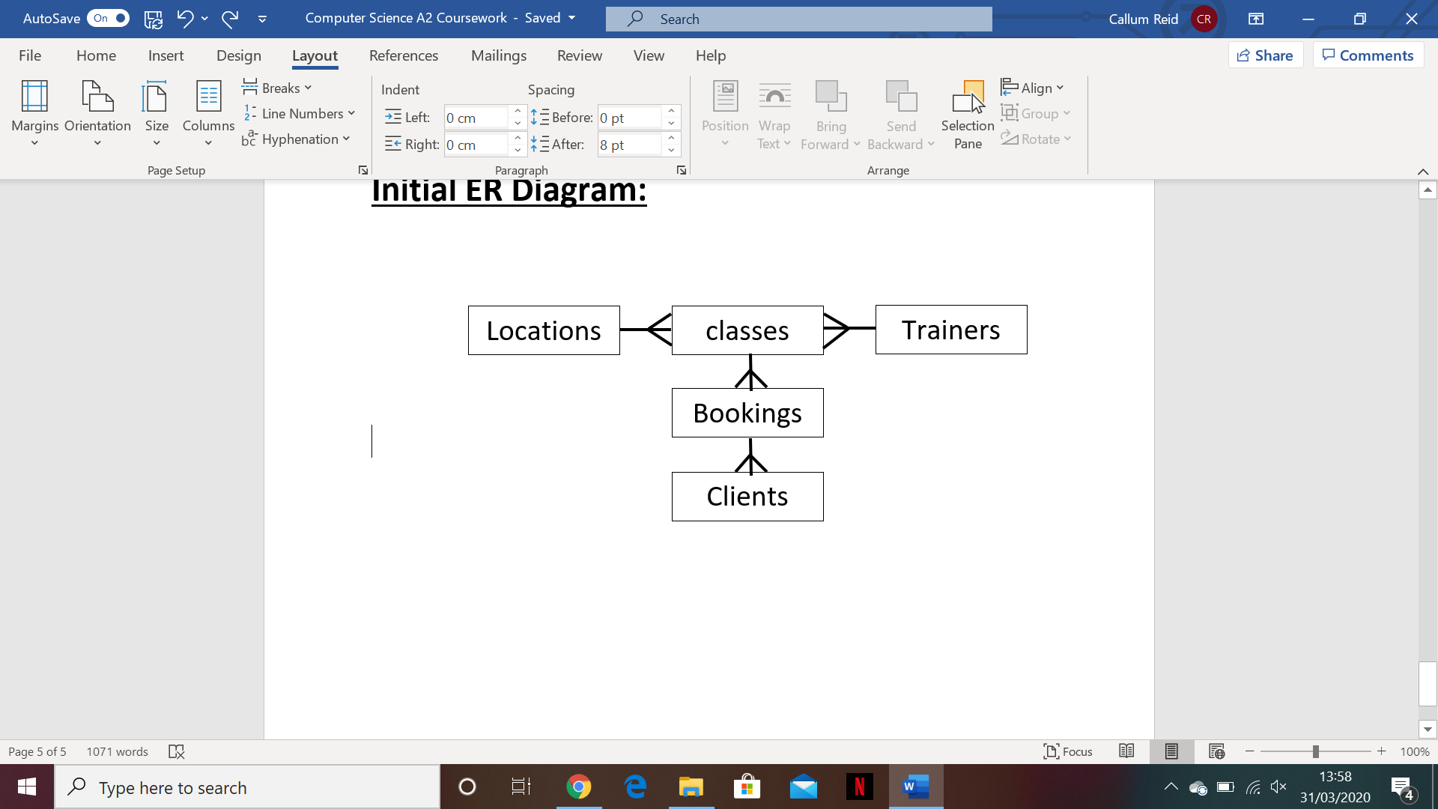

**Potential Limitations Of My Solution:**

There are currently several limitations to my solution, the first of which is that there is currently no way to securely transfer money through python and therefore the system cannot fully automate the financial side of the company. To combat this one of the reports which the manager can generate should show him all previous and upcoming bookings and highlight the ones which have not been paid for as of yet.

Another limitation is that I cannot access the real data of clients or trainers from Bayburn fitness so all data about trainers and clients will be made up in an attempt to test the system as realistically as possible.

Thirdly, the system requires a manager to add clients to the system to ensure the correct personal details have been added however this limits the rate at which people can join the system. It also means that people have to be registered onto the system before they can attend a class.

The program needs to be accessed over several different sites, I will not be able to test this properly as I will only use my own device to create the program.

**Power Point Presentation:**

In this power point I will highlight the problems displayed by the current Bayburn Fitness system and explain the system I propose as a solution. I will also discuss limitations of my system and ask for feedback from my peers. I will then analyse the feedback and either reject it as something that I think is unreasonable for the system or accept it and attempt to alter the system around this feedback.

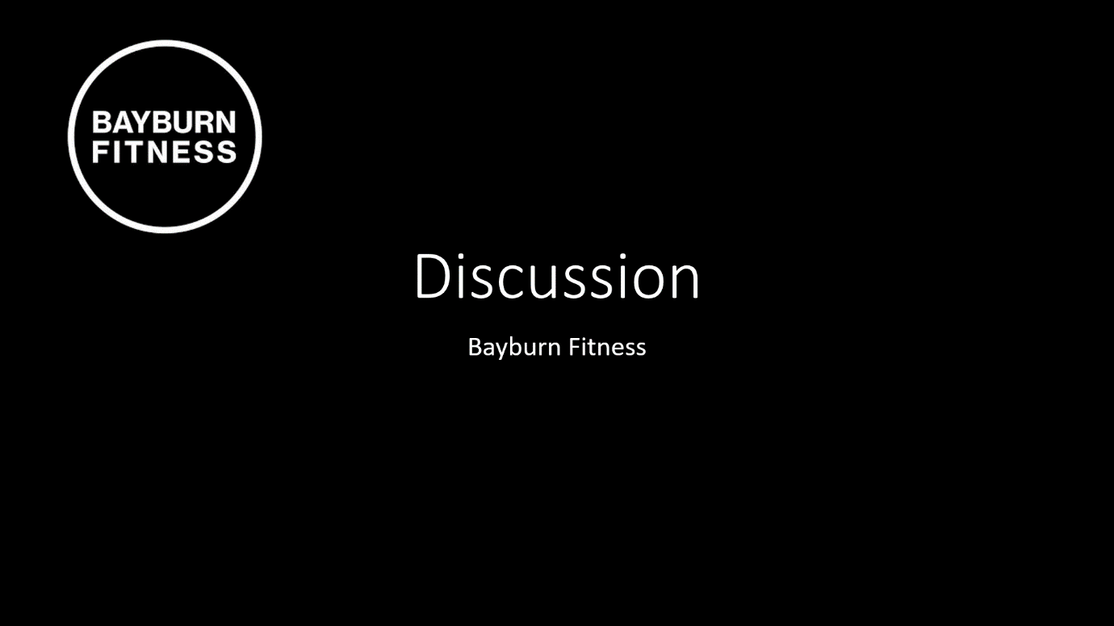

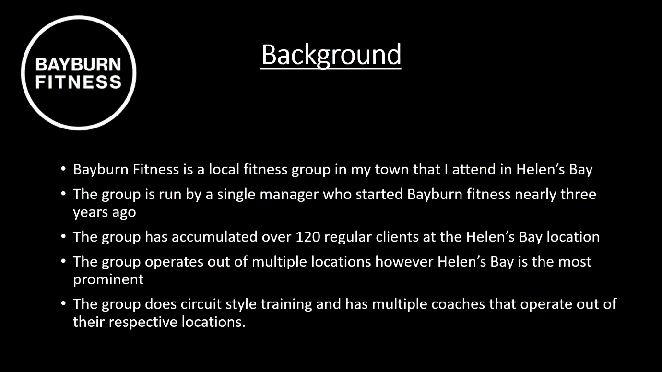

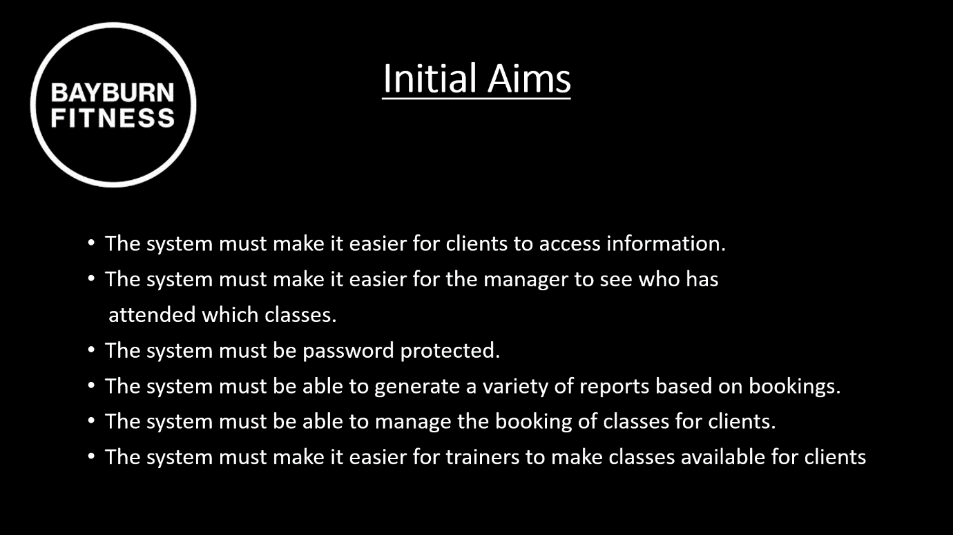

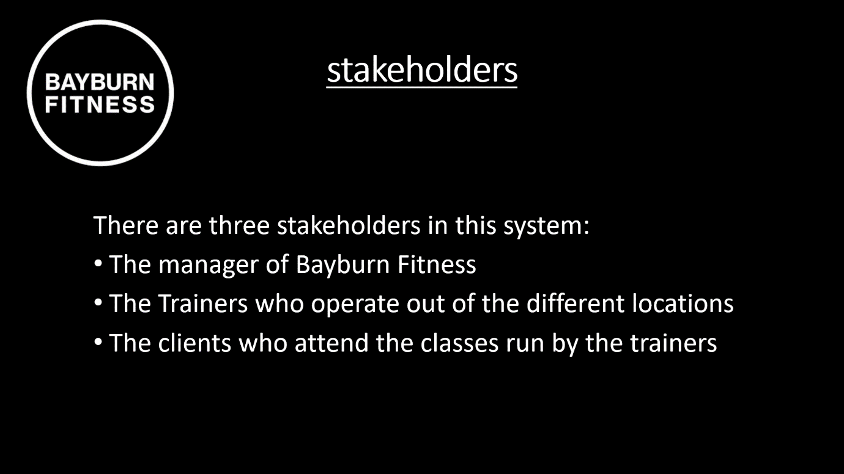

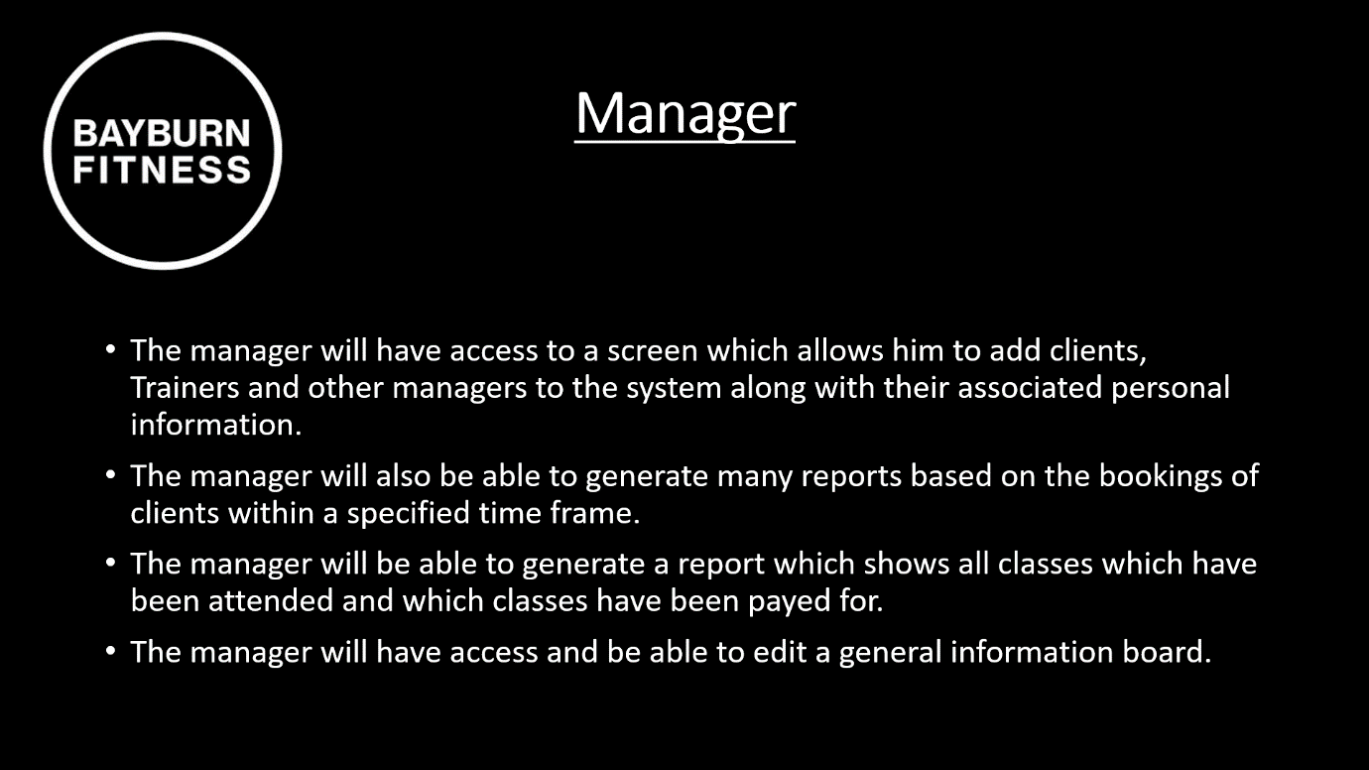

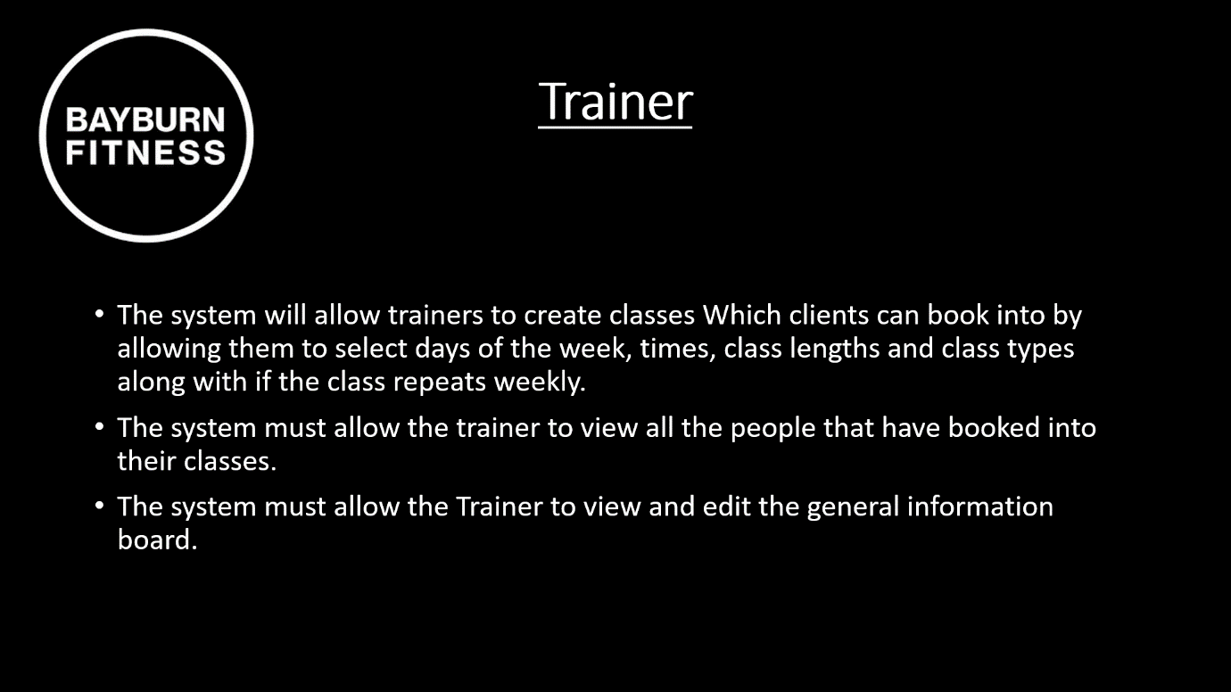

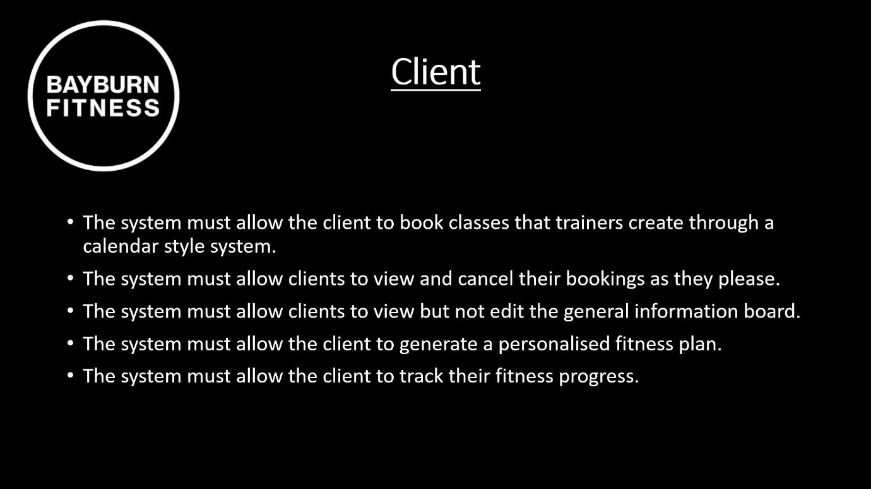

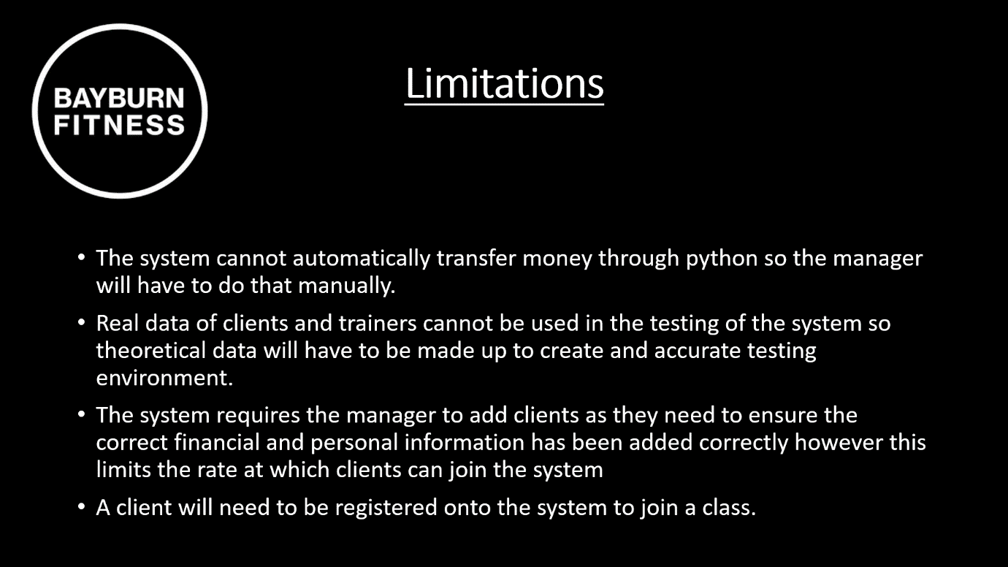





|  |  |  |  |
| --- | --- | --- | --- |
| **Feedback** | **Accept/Decline** | **Justification** | **Action to be taken** |
| Will you be storing medical information about clients? | Accepted | It is really important that i store medical information regarding the client in case anything happens the company will need to know in case there is any underlying conditions. | When creating the GUI and the database make sure that there is a place to store this data. |
| Will you be putting an age limit on the ages of clients? | Decline | I will not be putting an age limit on clients due to Bayburn fitness already accommodating for people of any age. | N/A |
| Will you be storing information regarding a clients next of kin? | Decline | I will not be storing this type of data as there is no situation where Bayburn fitness as a company would need to directly contact the next of kin of a client. | N/A |
| Will clients be able to log onto the system and book their own class | Accept | Clients will be able to book their own classes through the system. | When a client logs in they should be greeted with a calendar style system which allows them to see all possible class bookings for a selected day, they should then be able to book these classes. |
| Will you encrypt sensitive personal information? | Accept | In this system I will be storing sensitive medical information which needs to be protected. | I must implement encryption into the MySQL database, and the transfer of data between MySQL and the system |
| Will you be sending emails and text messages automatically when a class is booked? | Accepted | This will be useful as a way to let clients know that their class has been successfully booked. | The system must implement an email or SMS messaging system to send messages when a class is booked. |
| Will the system have a calendar in it and will the system automatically email a client on the day of their class? | Accepted | This will be a useful reminder for clients to go to their classes. | The system must implement an email or SMS messaging system to send messages when a class is upcoming. |
| Will the trainer mark the client as being present in the class? | Accepted | This will allow the manager to see what people have attended classes which will help him organise payments. | The system must have a GUI element that allows a trainer to mark people as present in a class. |
| When a trainer or client logs in will there be a personalised calendar telling them what is on for them that day? | Accepted | This will allow clients and trainers to see any bookings or upcoming classes they have. | The system must include a GUI element for trainers and clients to show them upcoming events. |
| Will the manager be able to produce a report regarding attendance to classes | Accepted | This will allow the manager to see who booked what classes and of those people who actually attended. This will help him see what cases do better than others. | The system must include a GUI element to show the bookings and attendance of clients. |
| Will the manager be able to produce a report regarding best and worst classes or most popular/lest popular classes? | Accepted | This will allow managers to see what classes work best and what classes aren’t as popular. | The system must include a GUI element to show the bookings of classes and then order them based on number of bookings. |
| Will the system be able to produce bar charts - if so for what? | Accepted | The system should be able to do this for showing number of bookings per class | The system must include a GUI element to show a bar chart with all necessary information on it |
| Will the system be able to produce pie charts - if so for what? | Declined | The system will be able to show all necessary information in the form of bar charts or other charts. | N/A |
| Will the system be able to send emails with attachments - if so what types of emails will be sent using attachments? | Decline | I do not see the need for attachments to be sent via email when the necessary information can be displayed by the system itself. | N/A |
| Will the client be able to pay for things online - you have said that this is a limitation - how will you overcome this? | Accept | Python cannot transfer money however the system should be able to keep track of payments. | The system will be able to keep track of payments that need to be made or that have been made as to help the manger keep track of his payments. |
| Will the system be able to produce any written reports - if so what types of written reports will you produce? | Accept | This would be useful as it would allow the reports to be analysed without internet connection | The system will need a feature that allows reports to be exported to word documents or excel spreadsheets. |
| Will the client be able to remove themselves from a class or edit a booking? | Accept | This is necessary in case of emergencies or other events that prevent a client from attending a class. | The system will need a GUI element to help edit bookings. |

|  |  |  |  |
| --- | --- | --- | --- |
| Will the client be able to book a class for someone else? | Decline | As there are currently no age limits on who can join Bayburn fitness young people may not be immature and misuse this feature. | N/A |
| Will the system be able to take data from the database and place it into excel spreadsheets? | Accept | This will be useful for the manager to view his reports whilst offline. | The system will need a feature that allows reports to be exported to word documents or excel spreadsheets. |
| Will managers and trainers have different views when they log on? | Accept | The managers and trainers have remarkably different roles on the system and so their GUI’s will be highly different. | The system will have to have 2 separate GUIs for managers and trainers. |
| Will a client be able to track results and see their progress? | Accept | This will be useful as it will help a client keep track of their fitness. | The system must have a GUI element that tracks and displays client fitness progress. |
| Who is going to manage the employees/trainers e.g. the adding deleting retrieving updating of employees? | Accept | The manager will manage the adding of clients, trainers and other managers. | The system will have a GUI element for adding people into specific roles. |